Common-Source Amplifier with Resistor Load and Source Degeneration **____________________**

A Laboratory Report Presented to

**Prof. Aileen Caberos-Gumera**

Faculty, DEET

College of Engineering and Technology, MSU-IIT

**____________________**

Laboratory 2

ECE 130 - Introduction to Analog Integrated Circuit Design

**____________________**

**JEPH MARI M. DALIGDIG**

**INTRODUCTION**

Common source amplifier is probably the most widely used of all the circuit configurations for many applications, providing a high level of all-round performance.

The common source circuit provides medium input and output impedance levels. Both current and voltage gain can be described as medium, but the output is the inverse of the input, i.e. 180° phase change. This provides good overall performance and as such, it is often thought of as the most widely used configuration.

**OBJECTIVES**

The objective of this laboratory activity is to have a better understanding of the effects of additional components to the common-source configuration such as resistive loads and resistances at the source terminal of the device. Specifically, this activity aims to show their effect on the gain, gain bandwidth, and output of the said amplifier.

**PROCEDURE AND RESULTS**

**Step 1.**

Simulate the Vin – Vout DC transfer curve and the frequency response following the circuit configuration below**.**



**DC Analysis of CS Amplifier:**

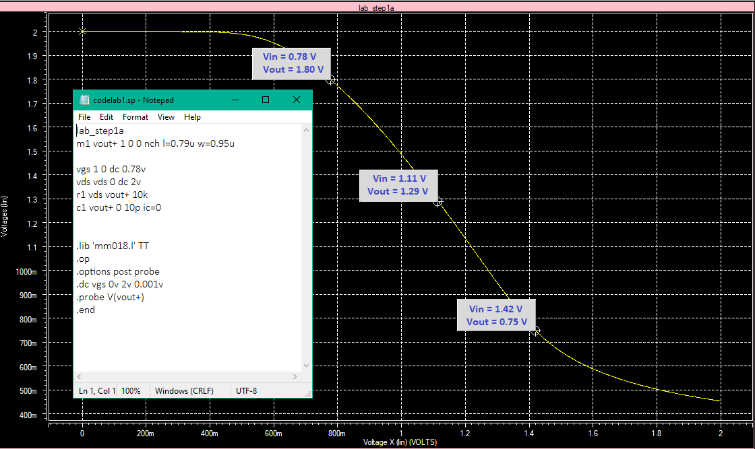

**AC Analysis of CS Amplifier:**

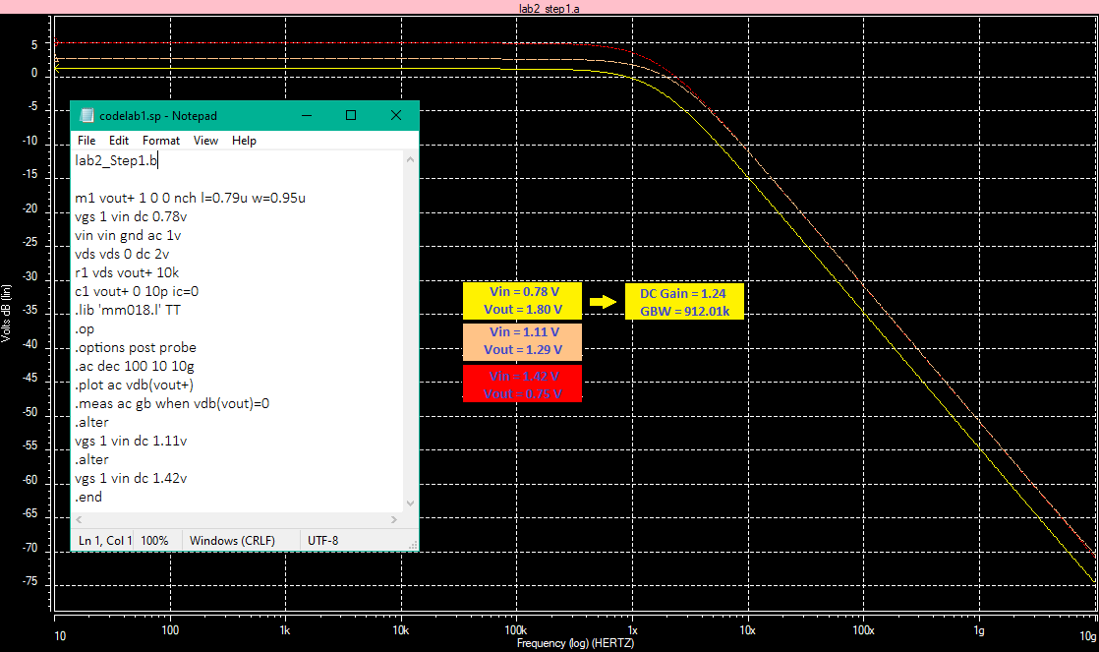

**Step 2**

Varying the values of R and simulating for the resulting waveforms of the circuit, with results listed in a table.

**AC Analysis of CS Amplifier with varying values of R.**

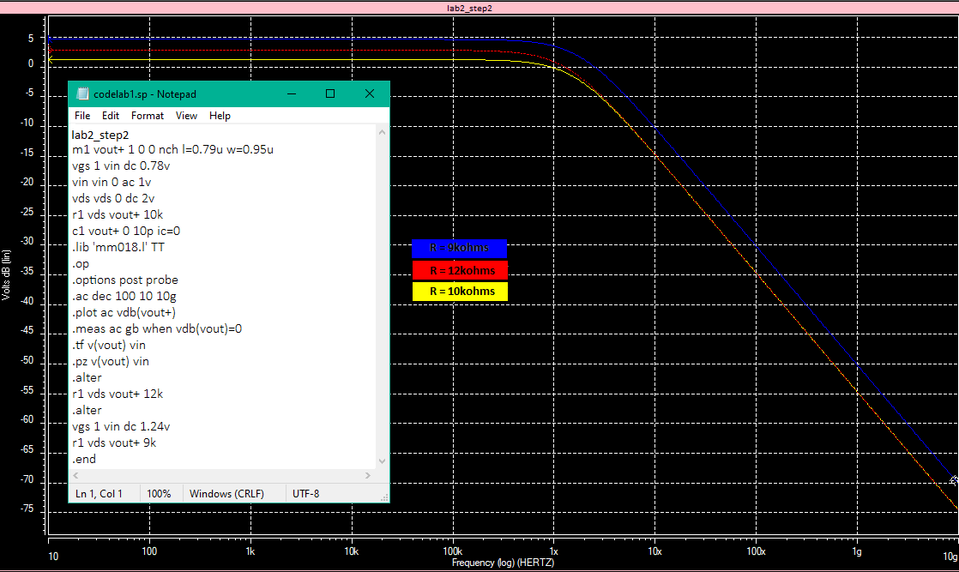

**Simulation results of CS Amplifier with different R values:**

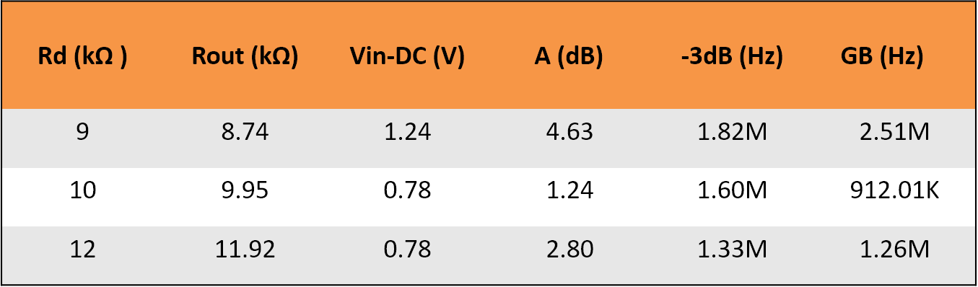

Based on the waveforms and the resulting values plotted on the table it is apparent that increasing the values of Rs will increase the DC gain of the Amplifier, including the output resistance, however in 9k it has a larger quantity of gain since it’s Vgs is increased which results to increased gain, including its Gain Bandwidth but the opposite for the -3db GBW.

**Step 3**

Simulate the Vin – Vout DC transfer curve and the frequency response following the circuit configuration below.



**DC Analysis of the CS Amplifier with S.D:**

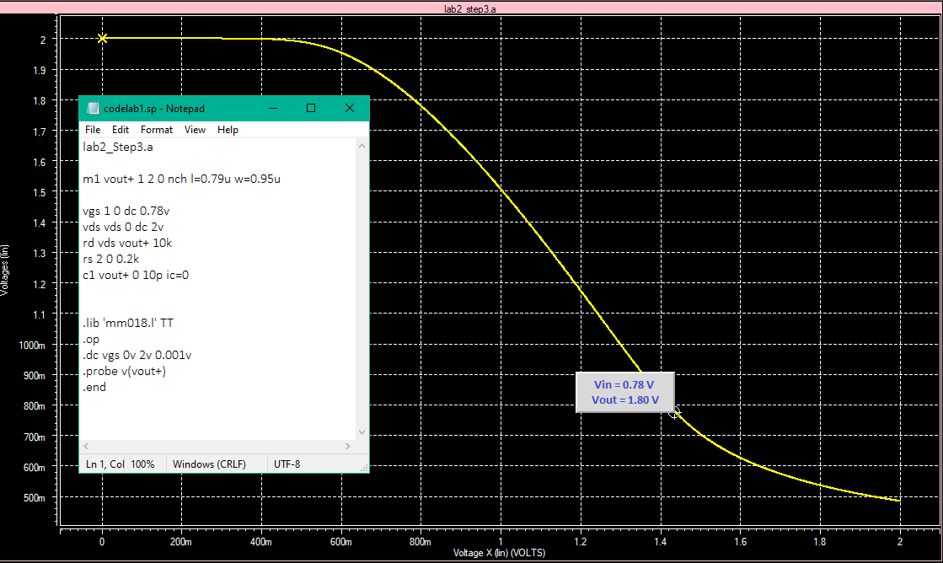

**AC Analysis of the CS Amplifier with S.D:**

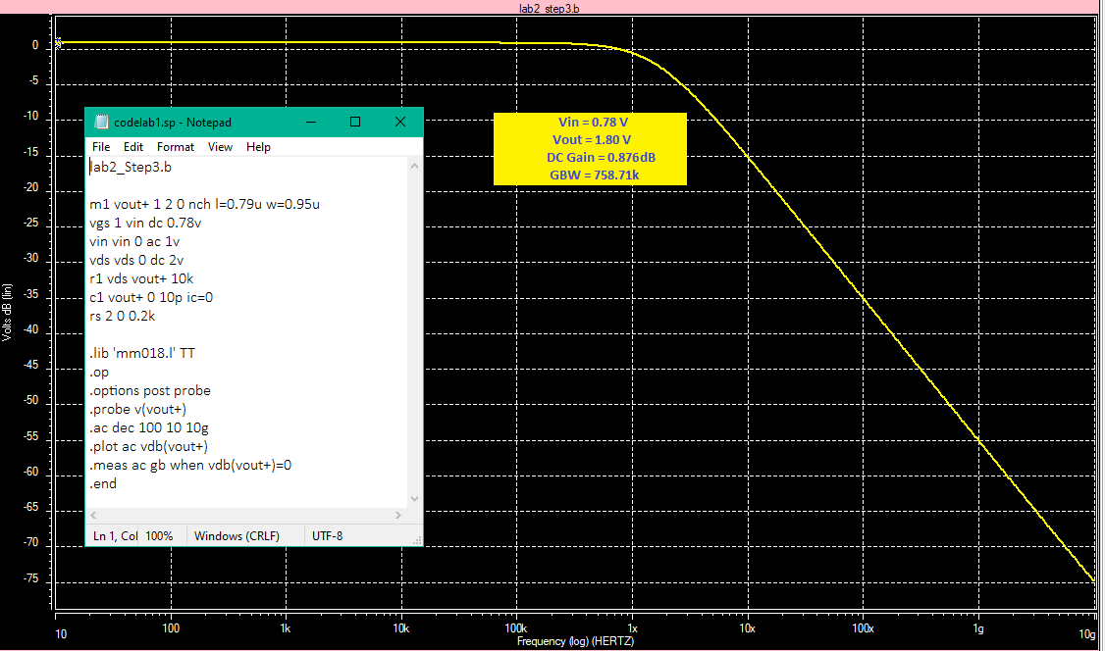

**Step 4**

Varying the values of rs using the cs amplifier with s.d and simulate for the waveforms and listing the results in a table.

**AC Analysis of CS Amplifier with S.D and varying values of Rs:**

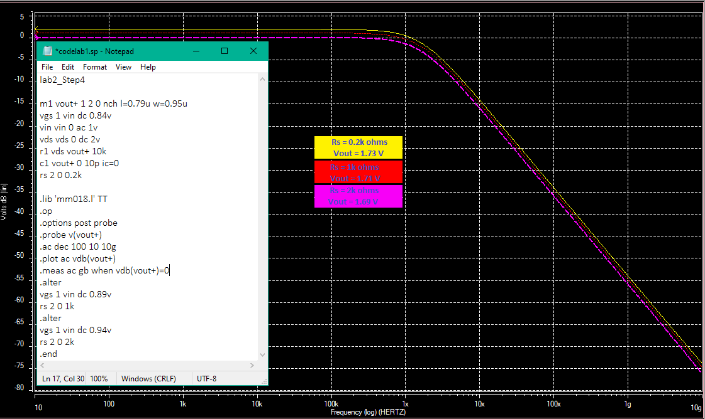

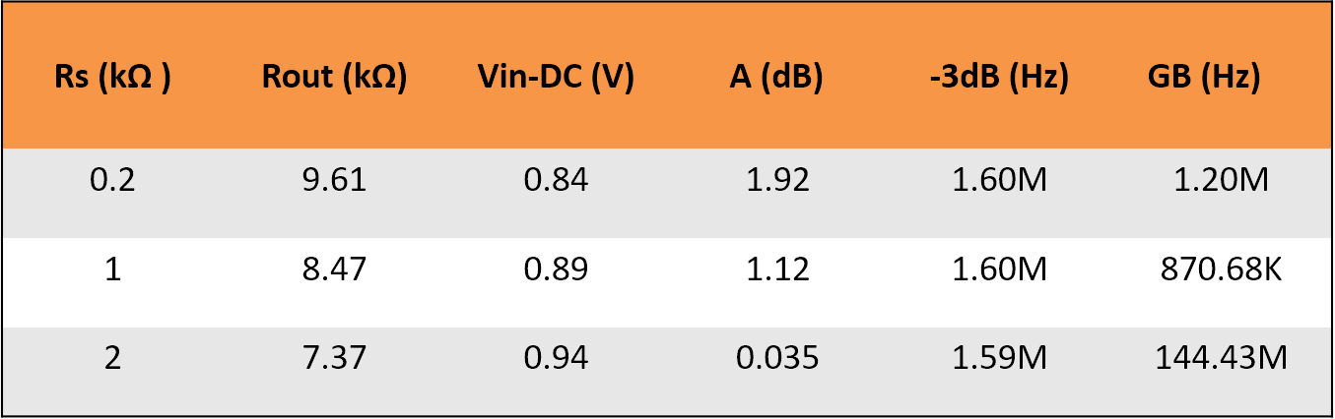**Simulation results of CS Amplifier with S.D with different Rs values:**

Varying rs values have significant changes on the DC gain it seems that as rs is increased the DC gain decreases as well as the output resistance. Having no resistance at the source terminal will give the highest value of DC gain possible.

**STEP 5**

Following the CS amplifier with S.D circuit by varying the values of Rs and simulating to produce the waveforms and listing the results in a table.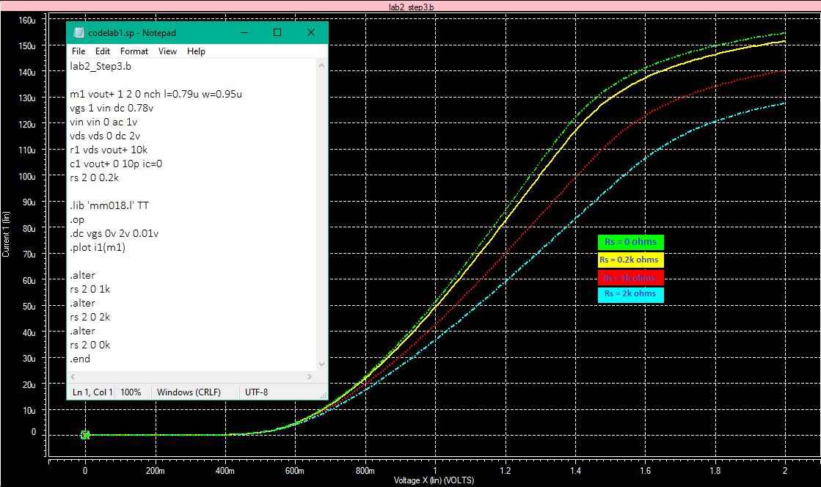

Based on the waveform it is apparent that there are significant changes on the Ids – Vgs curves. Having no resistance at the source provides the steepest curve possible.

**STEP 6**

Using the CS amplifier with S.D by having the input signal as an ideal sinusoidal wave with 0.05v amplitude, and the frequency as 100kHz. Performing FFT analysis to Vin to get the frequency spectrum and listing the results in a table.

**FFT Analysis of Vin:**

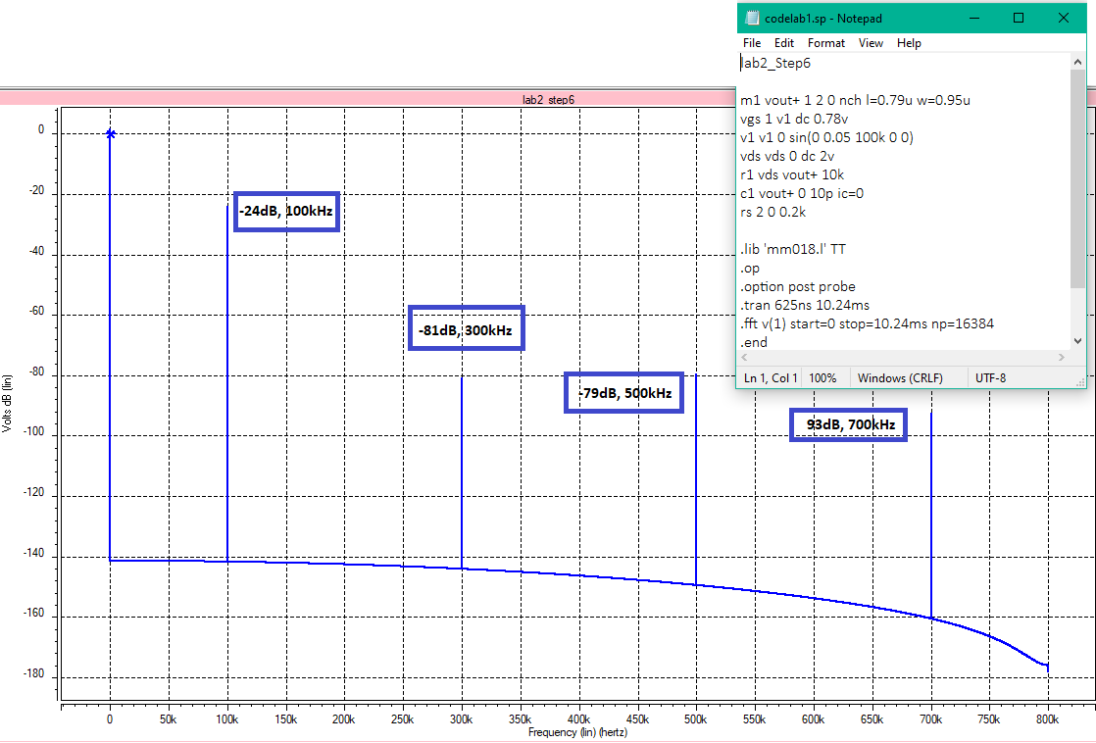

**Step 7**

Perform the FFT analysis to Vout of the same circuit as the previous step while varying the value of Rs to get the frequency spectrum.

**SPICE SYNTAX:**

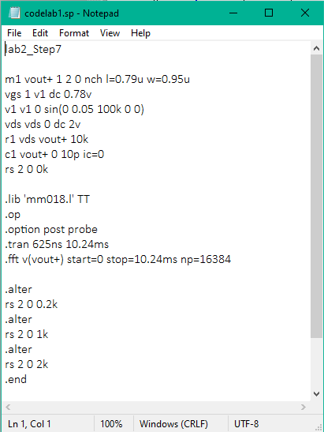

**FFT Analyses of Vout:**

**Rs = 0**

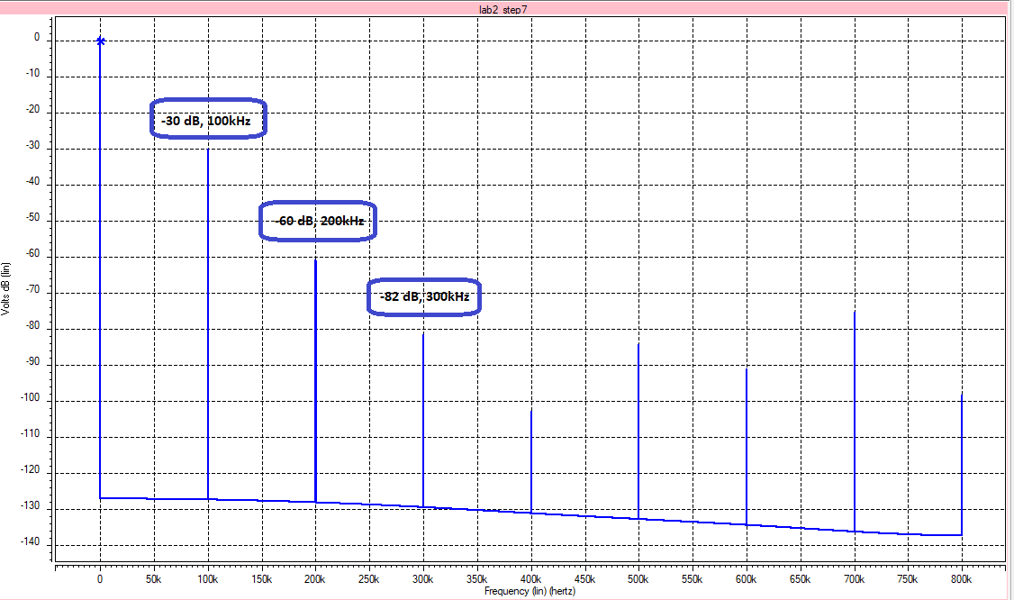

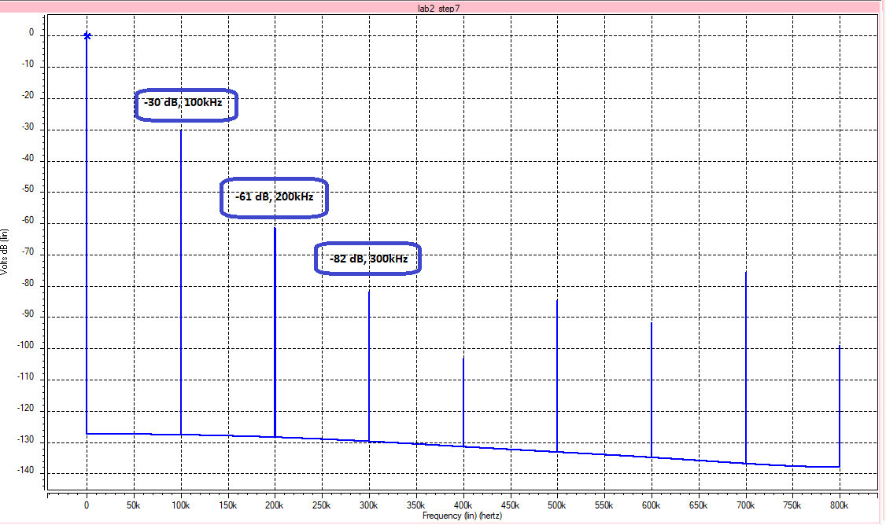**Rs = 0.2kΩ**

**Rs = 1kΩ**

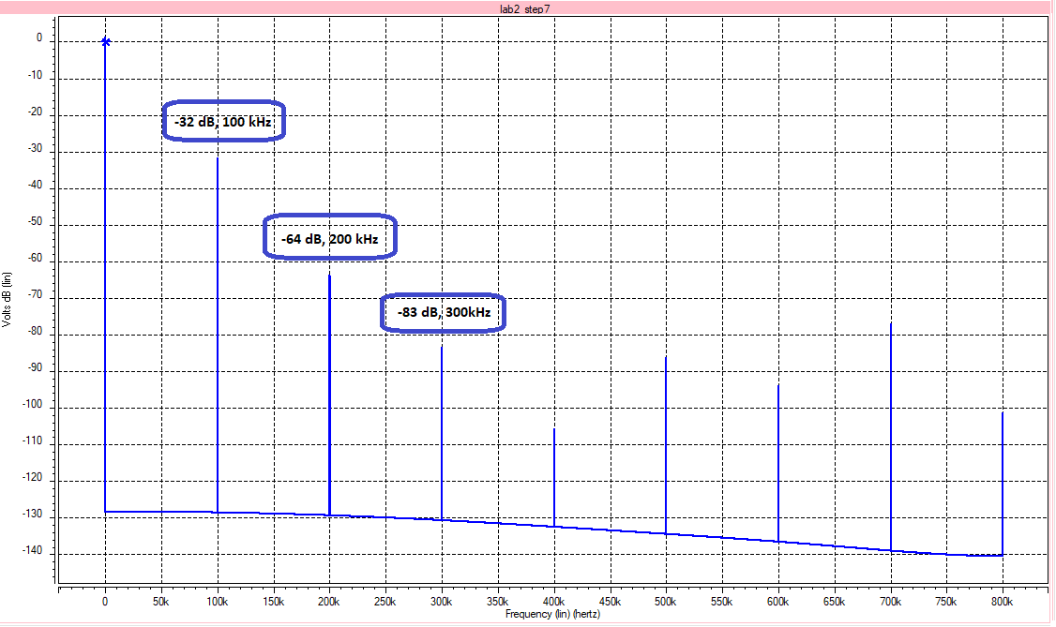

**Rs = 2kΩ**

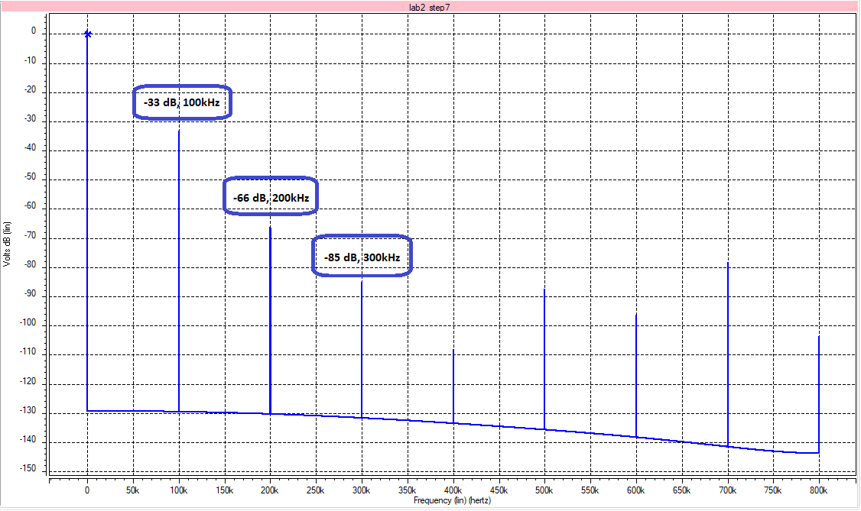

**Simulation results**



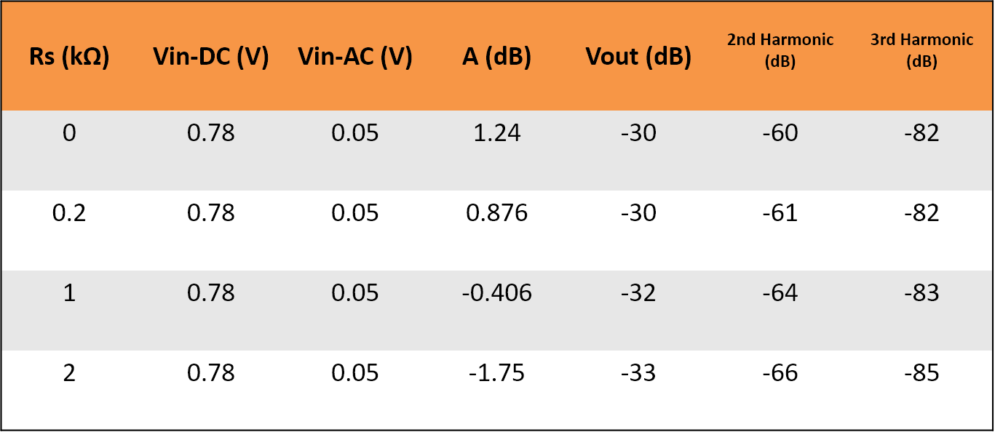

We could see that increasing values of the source resistance decreases the DC gain as well as the output voltage, it is apparent that from the 1st harmonic up to the last harmonic it will have a decreasing value.

**Questions**

1. How to increase the gain of common-source amplifier with resistive load? Explain what changes will occur to the circuit characteristics when we use those methods.

*It is obvious that increasing Vgs will also increase the gain of the amplifier as I have simulated from step 2, we could also increase the DC gain of the amplifier if we increase the value of the resistance in the drain, as a consequence also the output resistance increases. The same holds for the W/L of the device and for the drain current.*

1. Replace Rs in figure 4.11 by a diode-connected NMOS. Using the steps we followed before, what is the DC gain of this circuit?

By connecting a diode-connected NMOS on the source of M1, it is very important to increase Vgs of M1 in order to drive both the NMOS to saturation, the circuit resulted in a DC gain of -8.55dB which is a huge loss of gain. In conclusion, connecting a diode-connected NMOS to the source of another NMOS results in a degeneration of DC Gain.

1. Using the configuration of question 2, perform the FFT analysis of Vin and Vout to get the frequency spectrum of these waves. What happens to the circuit linearity? Is there any difference with figure 4.11?

**Vin:**

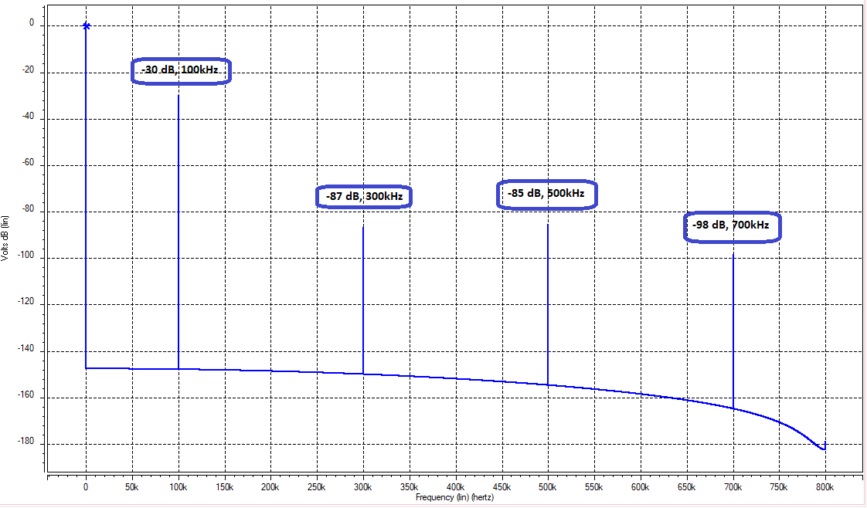

**Vout:**

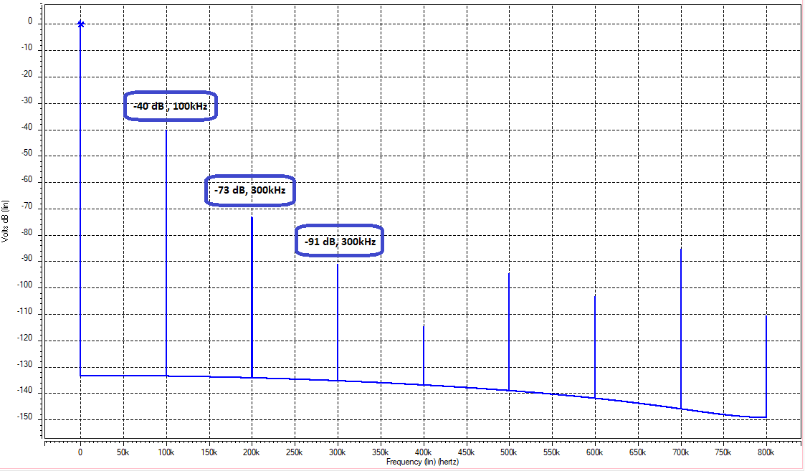

Based on the results we have a decrease in values of the harmonics of the Vin and Vout of the Circuit, however, the circuit still holds the linearity.